Types of Telescope – Telescopes are mainly classified on basis of energy of rays they are used to measure

1. Radio
2. UV ray
3. X-ray
4. Gamma ray
5. Cosmic ray
6. Neutrino detector
7. Particle detector
8. Gravitational wave detector

Cornograph - A telescope that is designed to block light coming from the solar disk, in order to see the extremely faint emission from the region around the sun, called the corona.

**Radio Telescopes**

Radio telescopes are typically large [parabolic ("dish") antennas](https://en.wikipedia.org/wiki/Parabolic_antenna) similar to those employed in tracking and communicating with [satellites](https://en.wikipedia.org/wiki/Satellite) and space probes. Since astronomical radio sources such as [planets](https://en.wikipedia.org/wiki/Planet), [stars](https://en.wikipedia.org/wiki/Star), [nebulas](https://en.wikipedia.org/wiki/Nebula) and [galaxies](https://en.wikipedia.org/wiki/Galaxy) are very far away, the radio waves coming from them are extremely weak, so radio telescopes require very large antennas to collect enough radio energy to study them, and extremely sensitive receiving equipment. Radio [observatories](https://en.wikipedia.org/wiki/Observatory) are preferentially located far from major centers of population to avoid [electromagnetic interference](https://en.wikipedia.org/wiki/Electromagnetic_interference) (EMI) from radio, [television](https://en.wikipedia.org/wiki/Television), [radar](https://en.wikipedia.org/wiki/Radar), motor vehicles, and other manmade electronic devices.

**X- ray Telescopes**

A **Wolter telescope** is a [telescope](https://en.wikipedia.org/wiki/Telescope) for [X-rays](https://en.wikipedia.org/wiki/X-ray) using only grazing incidence optics. X-rays mirrors can be built, but only if the angle from the plane of reflection is very low (typically 10 arc-minutes to 2 degrees). These are called *glancing (or grazing) incidence mirrors*. In 1952, [Hans Wolter](https://en.wikipedia.org/wiki/Hans_Wolter) outlined three ways a telescope could be built using only this kind of mirror. These are called Wolter telescopes of type I, II, and III. Wolter's key discovery was that by using two mirrors it is possible to create a telescope with a usably wide field of view. In contrast, a grazing incidence telescope with just one parabolic mirror could focus X-rays, but only very close to the centre of the field of view as it would suffer from extreme [coma](https://en.wikipedia.org/wiki/Coma_(optics)). In [optics](https://en.wikipedia.org/wiki/Optics) (especially [telescopes](https://en.wikipedia.org/wiki/Telescope)), the coma, or comatic aberration, in an optical system refers to [aberration](https://en.wikipedia.org/wiki/Aberration_in_optical_systems) inherent to certain optical designs or due to imperfection in the [lens](https://en.wikipedia.org/wiki/Lens_(optics)) or other components that results in off-axis [point sources](https://en.wikipedia.org/wiki/Point_source) such as stars appearing distorted, appearing to have a tail ([coma](https://en.wikipedia.org/wiki/Coma_(cometary))) like a [comet](https://en.wikipedia.org/wiki/Comet). Specifically, coma is defined as a variation in [magnification](https://en.wikipedia.org/wiki/Magnification) over the [entrance pupil](https://en.wikipedia.org/wiki/Entrance_pupil).

Type I

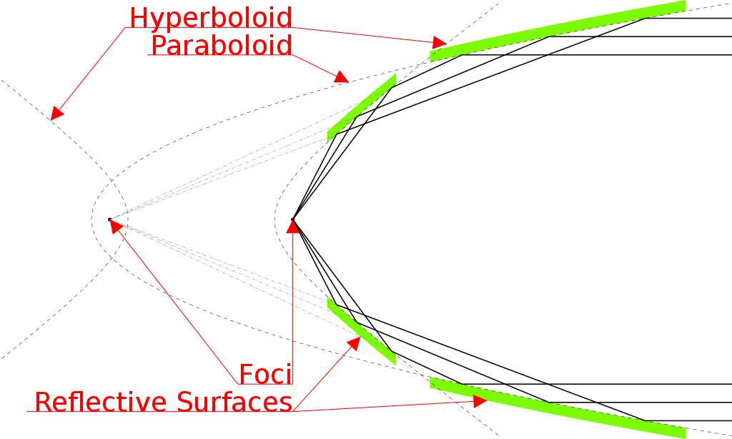

Type II

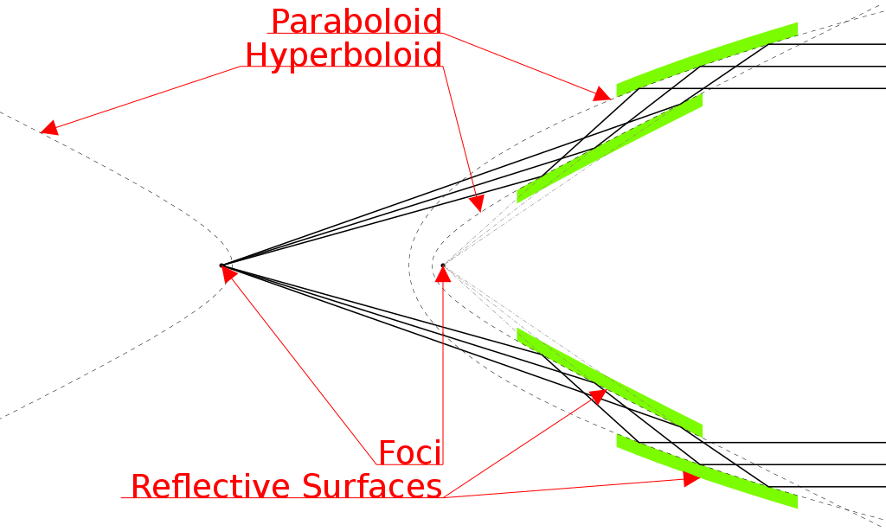

Type III

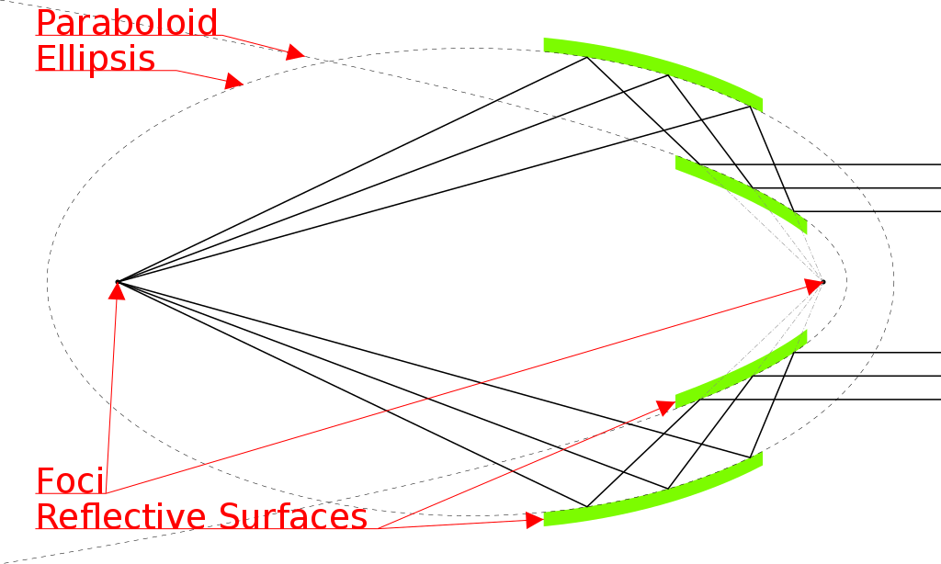

**UV ray Telescopes**

**Extreme ultraviolet coatings** (it is special type of multilayer optics**-**It is one or more thin layers of material deposited on an optical component such as a lens or mirror, which alters the way in which the optic reflects and transmits light**)**

In the EUV portion of the spectrum (wavelengths shorter than about 30 nm) nearly all materials absorb strongly, making it difficult to focus or otherwise manipulate light in this wavelength range. Telescopes such as TRACE or EIT that form images with EUV light use multilayer mirrors that are constructed of hundreds of alternating layers of a high-mass metal such as molybdenum or tungsten, and a low-mass spacer such as silicon, vacuum deposited onto a substrate such as glass. Each layer pair is designed to have a thickness equal to half the wavelength of light to be reflected. Constructive interference between scattered light from each layer causes the mirror to reflect EUV light of the desired wavelength as would a normal metal mirror in visible light. Using multilayer optics it is possible to reflect up to 70% of incident EUV light (at a particular wavelength chosen when the mirror is constructed).

**Gamma ray Telescopes**

Methods of detection for Gamma-rays

* Scintillation Detectors
* Solid State Detectors
* Compton Scattering
* Pair Telescopes(can’t be used in space)
* Air Cerenkov Detectors

[**Semiconductor detectors**](https://en.wikipedia.org/wiki/Semiconductor_detector), also called **solid-state detectors**, are fundamentally different from scintillation detectors: They rely on detection of the charge carriers (electrons and holes) generated in semiconductors by energy deposited by gamma ray photons. In semiconductor detectors, an electric field is applied to the detector volume. An electron in the semiconductor is fixed in its [valence band](https://en.wikipedia.org/wiki/Valence_band) in the crystal until a gamma ray interaction provides the electron enough energy to move to the [conduction band](https://en.wikipedia.org/wiki/Conduction_band). Electrons in the conduction band can respond to the electric field in the detector, and therefore move to the positive contact that is creating the electrical field. The gap created by the moving electron is called a "hole," and is filled by an adjacent electron. This shuffling of holes effectively moves a positive charge to the negative contact. The arrival of the electron at the positive contact and the hole at the negative contact produces the electrical signal that is sent to the preamplifier, the MCA, and on through the system for analysis. Common semiconductor-based detectors include [germanium](https://en.wikipedia.org/wiki/Germanium), [cadmium telluride](https://en.wikipedia.org/wiki/Cadmium_telluride), and [cadmium zinc telluride](https://en.wikipedia.org/wiki/Cadmium_zinc_telluride). Germanium detectors produce the highest resolution commonly available today. However, a disadvantage is the requirement of [cryogenic](https://en.wikipedia.org/wiki/Cryogenic) temperatures for the operation of germanium detectors, typically by cooling with [liquid nitrogen](https://en.wikipedia.org/wiki/Liquid_nitrogen).

A **pair-conversion** instrument detects high-energy gamma rays by providing an environment—generally a thin foil of dense metal, commonly tungsten—in which they tend to generate [electron](https://en.wikipedia.org/wiki/Electron)-[positron](https://en.wikipedia.org/wiki/Positron) pairs, and then using standard particle-physics techniques such as a [microstrip detector](https://en.wikipedia.org/wiki/Microstrip_detector) to detect these particles. A **microstrip detector** is a particle detector designed to consist of a large number of identical components laid out along one axis of a two-dimensional structure, generally by [lithography](https://en.wikipedia.org/wiki/Lithography). The idea is that several components will react to a single passing particle, allowing an accurate reconstruction of the particle's track. Silicon microstrip detectors, in which the sensing mechanism is the production of electron-hole pairs in a 300-micrometre layer of [silicon](https://en.wikipedia.org/wiki/Silicon), with the [electrons](https://en.wikipedia.org/wiki/Electron) then being attracted by an electric field created by a pattern of interdigitated anodes and cathodes on the surface of the silicon separated by SiO2 insulator, are a common design. At the bottom of the stack one commonly finds a [calorimeter](https://en.wikipedia.org/wiki/Calorimeter_(particle_physics)) capable of measuring the energy of the electron and the positron and inferring the energy of the incoming gamma ray. An anticoincidence shield of some kind is needed so that charged particles entering the device from outside are not confused with electron-positron pairs generated in the conversion foils. Space-based pair-conversion detectors tend to make for rather expensive missions, since they unavoidably contain several hundred kilograms of lead or tungsten.

**Cosmic ray telescope**

[**Neutrino telescope**](https://en.wikipedia.org/wiki/Neutrino_telescope)

A neutrino detector is a physics apparatus which is designed to study neutrinos. Because neutrinos only weakly interact with other particles of matter, neutrino detectors must be very large to detect a significant number of neutrinos. Neutrino detectors are often built underground, to isolate the detector from cosmic rays and other background radiation.[1] The field of neutrino astronomy is still very much in its infancy – the only confirmed extraterrestrial sources so far are the Sun and supernova SN 1987A.

**Gravitational-wave detector**

A **gravitational-wave observatory** is any device designed to measure [gravitational waves](https://en.wikipedia.org/wiki/Gravitational_waves), tiny distortions of [spacetime](https://en.wikipedia.org/wiki/Spacetime) that were first predicted by [Einstein](https://en.wikipedia.org/wiki/Albert_Einstein) in 1916. Gravitational waves are perturbations in the theoretical curvature of spacetime caused by accelerated masses. The existence of gravitational radiation is a specific prediction of [general relativity](https://en.wikipedia.org/wiki/General_relativity), but is a feature of all theories of gravity that obey [special relativity](https://en.wikipedia.org/wiki/Special_relativity).

**Structure of usual telescopes**

Telescope consists of following parts:

1) Eyepiece

2) Arm

3) Objective

4) Coarse Adjustment

5) Fine Adjustment

6) Body Tube

7) Stage

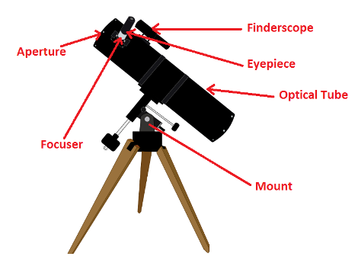

2 types of mount:

1. An altazimuth or alt-azimuth mount is a simple two-[axis](https://en.wikipedia.org/wiki/Coordinate_axis) mount for supporting and rotating an instrument about two [perpendicular](https://en.wikipedia.org/wiki/Perpendicular) axes – one vertical and the other horizontal
2. An equatorial mount is a mount for instruments that compensate the rotation of earth by having one rotational axis parallel to the Earth's axis of rotation.[[1]](https://en.wikipedia.org/wiki/Equatorial_mount#cite_note-1)[[2]](https://en.wikipedia.org/wiki/Equatorial_mount#cite_note-2) This type of mount is used for astronomical [telescopes](https://en.wikipedia.org/wiki/Telescopes) and [cameras](https://en.wikipedia.org/wiki/Camera). The advantage of an equatorial mount lies in its ability to allow the instrument attached to it to stay fixed on any object in the sky that has a [diurnal motion](https://en.wikipedia.org/wiki/Diurnal_motion) by driving one axis at a constant speed. Such an arrangement is called a sidereal drive.